## Creating a Dynamic Inventory using the Nautobot GraphQL Dynamic Inventory Plugin

To facilitate the creation of a dynamic inventory using Nautobot, we will provide use Nautobot's GraphQL dynamic inventory plugin for Ansible. GraphQL is a powerful data query language for APIs that allows users to specify the exact data they require for a particular task. Dynamic inventories, as opposed to static inventories, enable us to keep track of all our onboarded devices and facilitate the application of configuration changes as our network expands. By combining the power of GraphQL with Ansible, we can create an inventory that is highly scalable and surpasses the limitations of a static Ansible inventory file.

1. On the desktop-linux-1-vm instance in Google Cloud, open the Terminal and execute the following commands to install Ansible on the instance:
   * sudo apt update
   * sudo apt install software-properties-common
   * sudo add-apt-repository --yes --update ppa:ansible/ansible
   * sudo apt install ansible

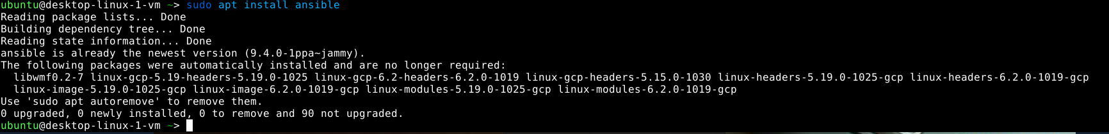

1. Install the required packages for the Nautobot Ansible collection:
   * sudo apt install python3-pip
   * sudo pip install netutils

1. Switch to the **/etc/ansible** directory.

1. Use the **chmod** command to change the file permissions of the **ansible.cfg** file.

1. Create a complete initial Ansible configuration using the **ansible-config** command.

ansible-config init --disabled -t all > ansible.cfg

1. Install the Nautobot galaxy collection using the command **ansible-galaxy collection install networktocode.nautobot**. This installs our dynamic inventory plugin alongside other Ansible modules for Nautobot.

1. On a web browser, navigate to the internal IP address of the Nautobot instance and login.
2. In the Nautobot GUI, navigate to Admin > Profile > API Tokens

1. Click “**Add a token**”

1. Click **Create** to accept the default settings. This will create an API token so that GraphQL can query Nautobot for information. This token will never expire. Keep this token handy in a text file as we will use it later.

1. Right-click on the desktop to create a folder named **ansible-gql**. We will use this folder to store our dynamic inventory and Ansible playbooks.

1. Open the ansible-gql folder and create a YAML configuration file for the dynamic inventory plugin. We will name it **inventory.yml**.

1. Open **inventory.yml** in Visual Studio Clde by right-clicking on the file and selecting **Open With “Visual Studio Code”**

1. Enter the following configuration details for the dynamic inventory plugin into the file:

plugin: networktocode.nautobot.gql_inventory

api_endpoint: https://<IP_of_nautobot>

token: API token created from step 6

validate_certs: false

This is the minimum required configuration for the dynamic inventory plugin to work. The **validate_certs** parameter, while optional, is required for our environment because of Nautobot’s use of self-signed SSL/TLS certificates

1. Save the file by pressing CTRL+S
2. Use the command **ansible-inventory -v --list -i inventory.yml** to test the inventory plugin. Ansible will dynamically query Nautobot via GraphQL using the configuration details in inventory.yml and display information for each onboarded device in Nautobot.

